**Static Code Analysis**

* Peer Code Review  
  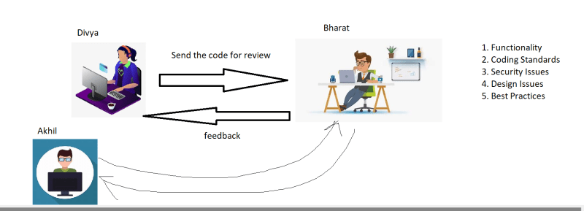
* Since a person is doing the review, mistakes can happen.
* Static Code Analysis tools take over certain responsibilites from Bharat
  + Coding Standards
  + Best Practices
  + Securiy Issues
  + Design Issues
  + Test Case Quality  
    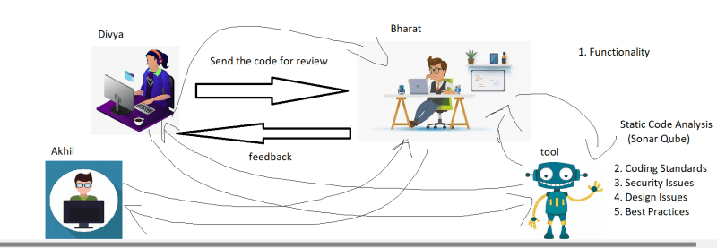
* If we can run this static code analysis with every change in the pipeline and
  + Phase-1 : Show the report generated
  + Phase-2: Fail the build if the agreed criteria is not met (Quality Gate)

**Testing By DevTeams**

* Unit Tests: Developers are expected to write tests to check the code developed by team
* When developers perform unit testing, there should be a way to measure the quality of unit tests.
* Line Coverage
* Branch Coverage
* Note: As a devops Engineer, we are expected to create Quality Gates around
  + Test Coverage
  + Static Code Analysis issues